**Practical 08**

**VMware Workstation Installation**

**Download and Install VMware Workstation Pro 16**

1. Go to <https://www.vmware.com/products/workstation-pro.html> to download VMware Workstation Pro 16.
2. Run the installer. Start the installer by double clicking it. You might see User Account Control warning. Click Yes to continue.
3. Follow the wizard to proceed. Click “Next”.

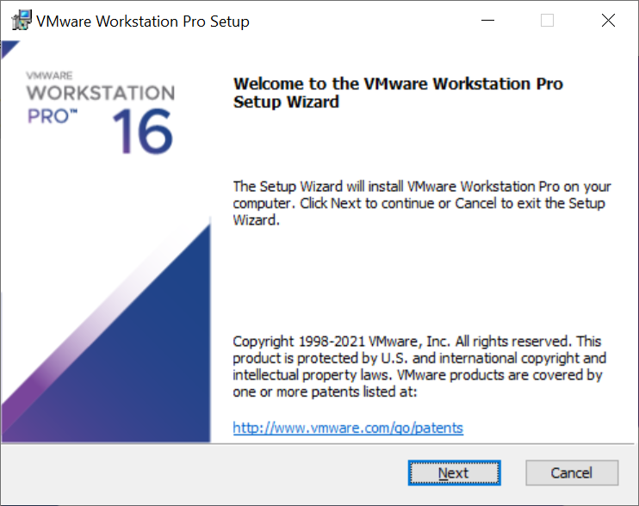

1. Check the box “I accept the terms in the License Agreement” and click “Next”.

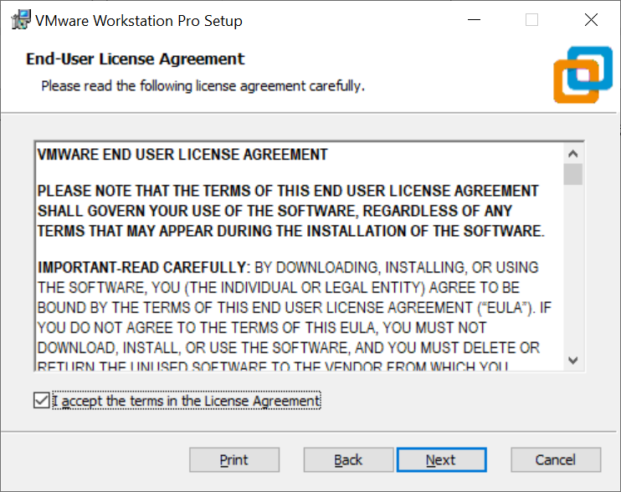

1. In this dialog box, select the folder in which you want to install the application. You may leave it as it is (i.e. use the default). Click “Next”.

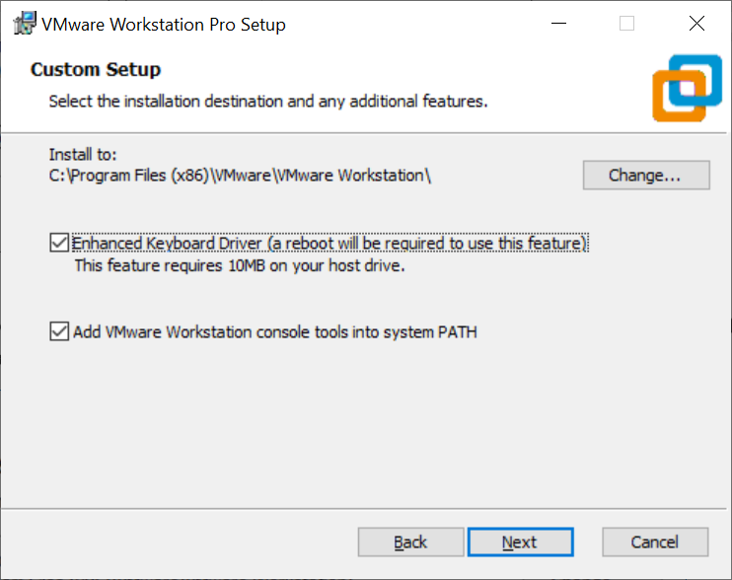

1. Check the options for “Check the product updates on startup” and “Join the VMware Customer Experience Improvement Program”. You may uncheck it if you so desire. Click “Next”.

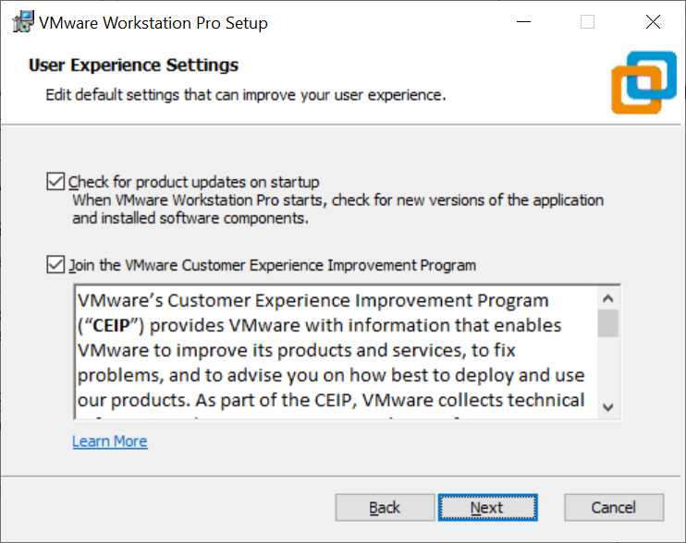

### Check the options for “Desktop” and “Start Menu Programs Folder”. You may uncheck it if you so desire. Click “Next”.

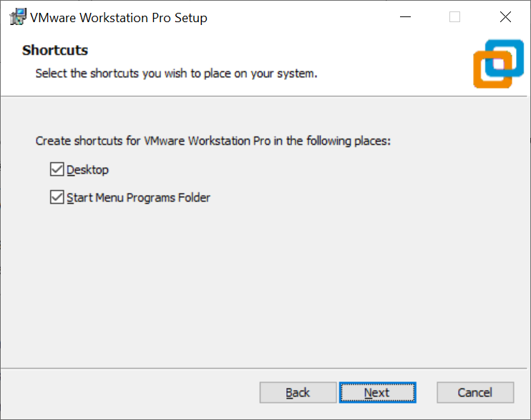

1. Now the installation wizard is ready to install. Click “Install” to begin the installation.

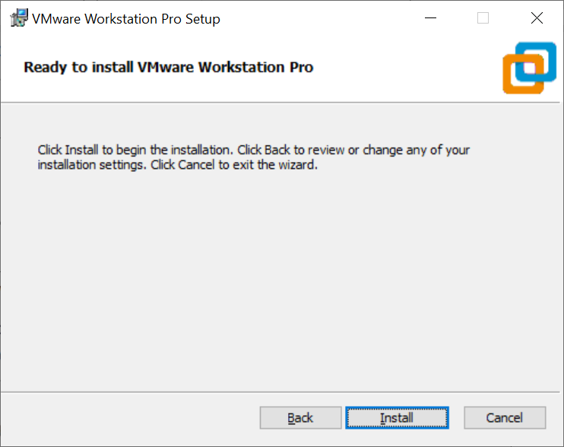

1. Installation begins, wait for it to complete.

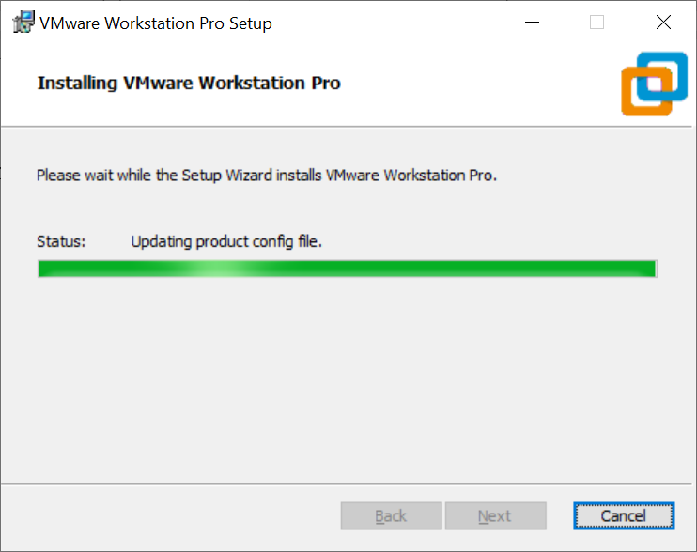

1. After sometime, you will see the installation completed message. You are done. Click “Finish” to complete the installation.

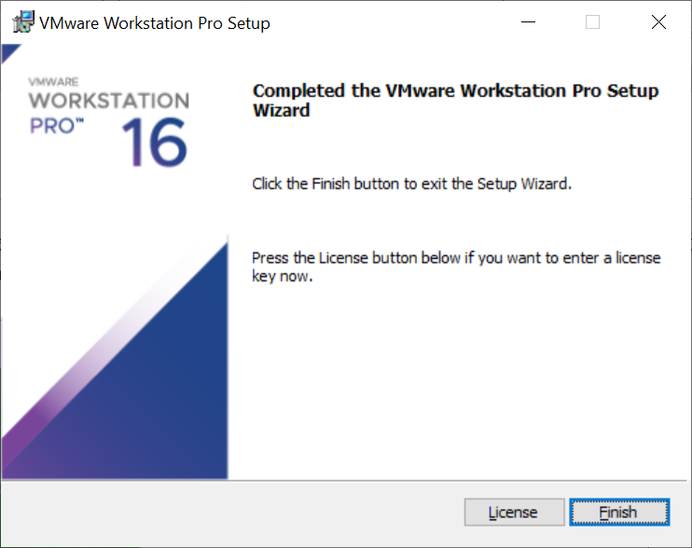

1. You will be asked to restart your system. Click “Yes” to restart or click “No” if you want to restart later. You **must** restart before using the application.

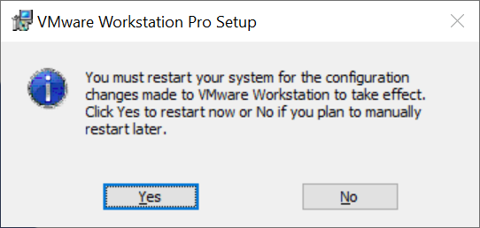

1. Run the application (after you have restart your system). You should see a WMware Workstation Pro icon on your Windows desktop. Double click on the icon or use the start menu to navigate to VMware Workstation Pro option.

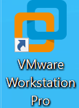

1. When you run the application for the first time, you will be asked for the licence key. **You can get the licence key from your lecturer.**

Enter the license key and click “Continue”.

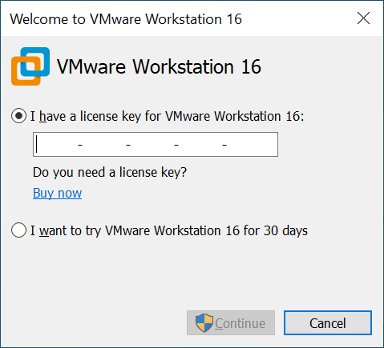

1. Click “Finish”.

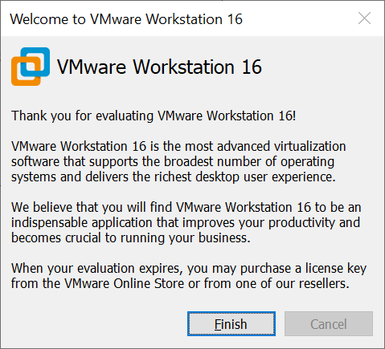

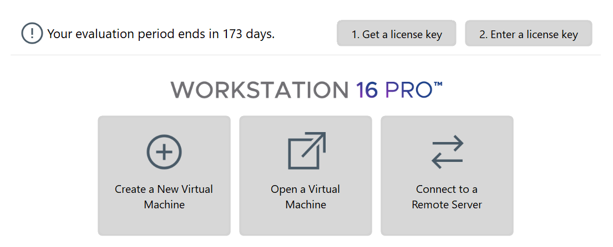

**You can now proceed to Practical 9 Linux Quick Tour**

*End of Practical*